EXPERIMENT 22
TRAIN TICKET RESERVATION SYSTEM TO RECEIVE TICKETS THROUGH SOCIAL NETWORK
AIM
To create an online train ticket booking system that generates the ticket and sends it to the WhatsApp number of the customer.

SQL DATACONNECT:
import sqlite3

conn = sqlite3.connect("Railway.db")
c = conn.cursor()
This line:
sqlite3.connect("Railway.db")
connects Python to the SQLite database file Railway.db.

PYTHON:
import sqlite3
import tkinter as tk
from tkinter import messagebox
import random
import time

# ---------------- DATABASE ----------------
conn = sqlite3.connect("Railway.db")
c = conn.cursor()

c.execute("""
CREATE TABLE IF NOT EXISTS train_details (
train_no INTEGER PRIMARY KEY,
train_name TEXT,
source TEXT,
destination TEXT
)
""")

c.execute("""
CREATE TABLE IF NOT EXISTS passenger_details (
id INTEGER PRIMARY KEY AUTOINCREMENT,
name TEXT,
age INTEGER,
source TEXT,
destination TEXT,
journey_date TEXT,
travel_class TEXT,
ticket_no TEXT
)
""")

c.execute("""
INSERT OR IGNORE INTO train_details
(train_no, train_name, source, destination)
VALUES
(101, 'Chennai Express', 'Howrah', 'New Delhi'),
(102, 'Rajdhani Express', 'Ajmer', 'Chandigarh')
""")

conn.commit()

# ---------------- LOGIN ----------------
def login_window():
root = tk.Tk()
root.title("Railway Reservation")
root.geometry("450x350")

tk.Label(
root,
text="BHAARATH RAILWAYS",
font=("Arial", 20, "bold")
).pack(pady=30)

tk.Label(root, text="Login ID").pack()
login_entry = tk.Entry(root)
login_entry.pack()

tk.Label(root, text="Password").pack(pady=(15, 0))
password_entry = tk.Entry(root, show="*")
password_entry.pack()

def login():
username = login_entry.get()
password = password_entry.get()

if username in ["dhoni", "jainam", "ayush"] and password == "844":
messagebox.showinfo("Login", "LOGIN SUCCESSFUL")
root.destroy()
journey_window()
else:
messagebox.showerror("Login", "LOGIN FAILED")

tk.Button(
root,
text="LOGIN",
command=login,
width=15
).pack(pady=25)

root.mainloop()

# ---------------- JOURNEY DETAILS ----------------
def journey_window():
window = tk.Tk()
window.title("Journey Details")
window.geometry("500x500")

tk.Label(
window,
text="ENTER JOURNEY DETAILS",
font=("Arial", 18, "bold")
).pack(pady=20)

# Source
tk.Label(window, text="Source").pack()
source_var = tk.StringVar(value="Select")
source_menu = tk.OptionMenu(
window,
source_var,
"Howrah",
"Ajmer"
)
source_menu.pack()

# Destination
tk.Label(window, text="Destination").pack(pady=(15, 0))
destination_var = tk.StringVar(value="Select")
destination_menu = tk.OptionMenu(
window,
destination_var,
"New Delhi",
"Chandigarh"
)
destination_menu.pack()

# Class
tk.Label(window, text="Class").pack(pady=(15, 0))
class_var = tk.StringVar(value="Select")
class_menu = tk.OptionMenu(
window,
class_var,
"1A",
"2A",
"3A"
)
class_menu.pack()

# Date
tk.Label(window, text="Date (DD/MM/YYYY)").pack(pady=(15, 0))
date_entry = tk.Entry(window)
date_entry.pack()

# Passenger name
tk.Label(window, text="Passenger Name").pack(pady=(15, 0))
name_entry = tk.Entry(window)
name_entry.pack()

# Age
tk.Label(window, text="Age").pack(pady=(15, 0))
age_entry = tk.Entry(window)
age_entry.pack()

def book_ticket():
source = source_var.get()
destination = destination_var.get()
travel_class = class_var.get()
journey_date = date_entry.get()
name = name_entry.get()
age = age_entry.get()

if (
source == "Select"
or destination == "Select"
or travel_class == "Select"
or journey_date == ""
or name == ""
or age == ""
):
messagebox.showerror("Error", "Enter all required fields")
return

# Check date
try:
day, month, year = map(int, journey_date.split("/"))

if not (1 <= day <= 31 and 1 <= month <= 12):
raise ValueError

except ValueError:
messagebox.showerror(
"Error",
"Enter date in DD/MM/YYYY format"
)
return

# Check unavailable routes similar to manual
if (
source == "Ajmer"
and destination in ["Chandigarh", "New Delhi"]
and travel_class == "3A"
):
messagebox.showerror(
"Error",
"Sorry Train Unavailable!"
)
return

# Generate ticket number
ticket_no = "T" + str(random.randint(10000, 99999))

c.execute("""
INSERT INTO passenger_details
(name, age, source, destination, journey_date, travel_class, ticket_no)
VALUES (?, ?, ?, ?, ?, ?, ?)
""", (
name,
int(age),
source,
destination,
journey_date,
travel_class,
ticket_no
))

conn.commit()

messagebox.showinfo(
"Ticket Confirmed",
f"Ticket Booked Successfully!\n\n"
f"Ticket No: {ticket_no}\n"
f"Name: {name}\n"
f"Source: {source}\n"
f"Destination: {destination}\n"
f"Class: {travel_class}\n"
f"Date: {journey_date}"
)

tk.Button(
window,
text="BOOK TICKET",
command=book_ticket,
width=20
).pack(pady=25)

window.mainloop()

# ---------------- START PROGRAM ----------------
login_window()

conn.close()

OUTPUT:

python railway.py

IMAGES:
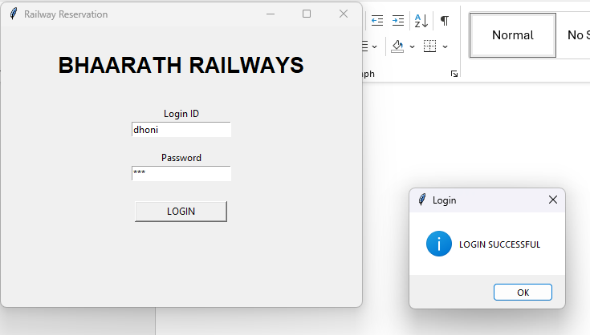



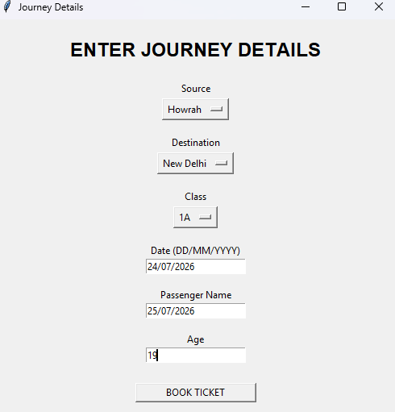

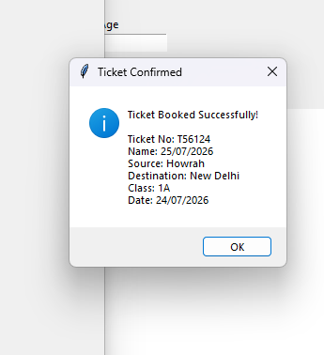

RESULT
Thus the Train Ticket Reservation System was successfully created using Python and SQLite, and the required ticket booking operations were executed successfully.

